|  |  |  |
| --- | --- | --- |
|  |  |  |
|  |  |  |
|  |  |  |

|  |  |  |
| --- | --- | --- |
| egg | майонез | beet |
| квашеная капуста | pickle | горошек |
| beef | картофель | salt |

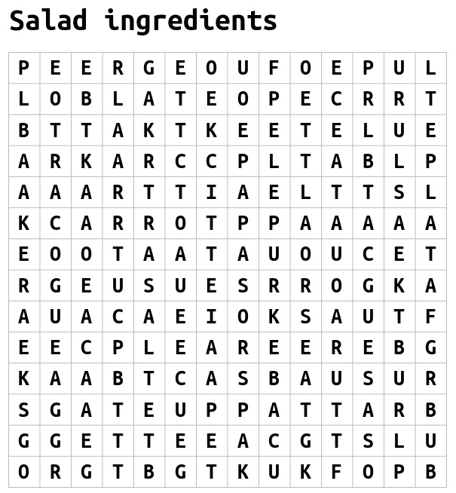

**соль горошек говядина морковь свекла яйцо**

**квашеная капуста картофель соленый огурец**

**Cooking actions**

|  |  |  |  |  |  |  |  |  |  |  |  |  |  |  |  |
| --- | --- | --- | --- | --- | --- | --- | --- | --- | --- | --- | --- | --- | --- | --- | --- |
|  |  |  |  |  |  |  |  | 1 |  |  |  |  |  |  |  |
|  |  |  |  |  |  |  | 2 |  |  | 3 |  | 4 |  |  |  |
|  |  |  |  |  |  |  |  |  |  |  |  |  |  |  |  |
|  |  |  |  | 5 |  |  | 6 |  |  |  |  |  |  |  |  |
|  |  |  |  |  |  |  |  |  |  |  |  |  |  |  |  |
|  |  |  |  |  |  | 7 |  |  |  |  |  |  |  |  |  |
|  |  |  |  |  |  |  |  |  |  |  |  |  |  |  |  |
|  |  |  | 8 |  |  | 9 |  |  | 10 |  |  |  |  |  |  |
|  |  |  |  |  |  |  |  |  |  |  |  |  |  |  |  |
|  | 11 |  |  |  |  |  |  |  |  |  |  |  |  |  |  |
|  |  |  |  |  |  | 12 |  |  |  |  |  |  |  |  |  |
|  |  |  |  |  |  |  |  |  |  |  |  |  |  |  |  |
| 13 |  | 14 |  |  |  |  |  |  |  |  |  |  |  |  |  |
|  |  |  |  |  |  |  |  |  |  |  |  |  |  |  |  |
|  |  | 15 |  |  |  |  |  |  |  |  |  |  |  |  |  |

|  |  |
| --- | --- |
| **Across**  **2.** To move from side to side or back and forth  **4.** To transfer liquid from one container to another  **5.** To mix egg, cream etc very fast using a fork  **7.** To make something ready to be used  **8.** To cut something into thin pieces  **11.** To bubble up and vaporize over direct heat  **12.** To cut away the rind  **13.** To warm something up  **15.** To cut into small cubes | **Down**  **1.** To prepare food by mixing, combining, and heating the elements or ingredients  **3.** To put something over a large surface, usually with a knife  **4.** To put in a particular spot  **6.** To present food or drink to somebody  **8.** To mix food  **9.** To cut into pieces  **10.** To make cold  **11.** To cook in the oven  **14.** To put something with another thing or group of things |

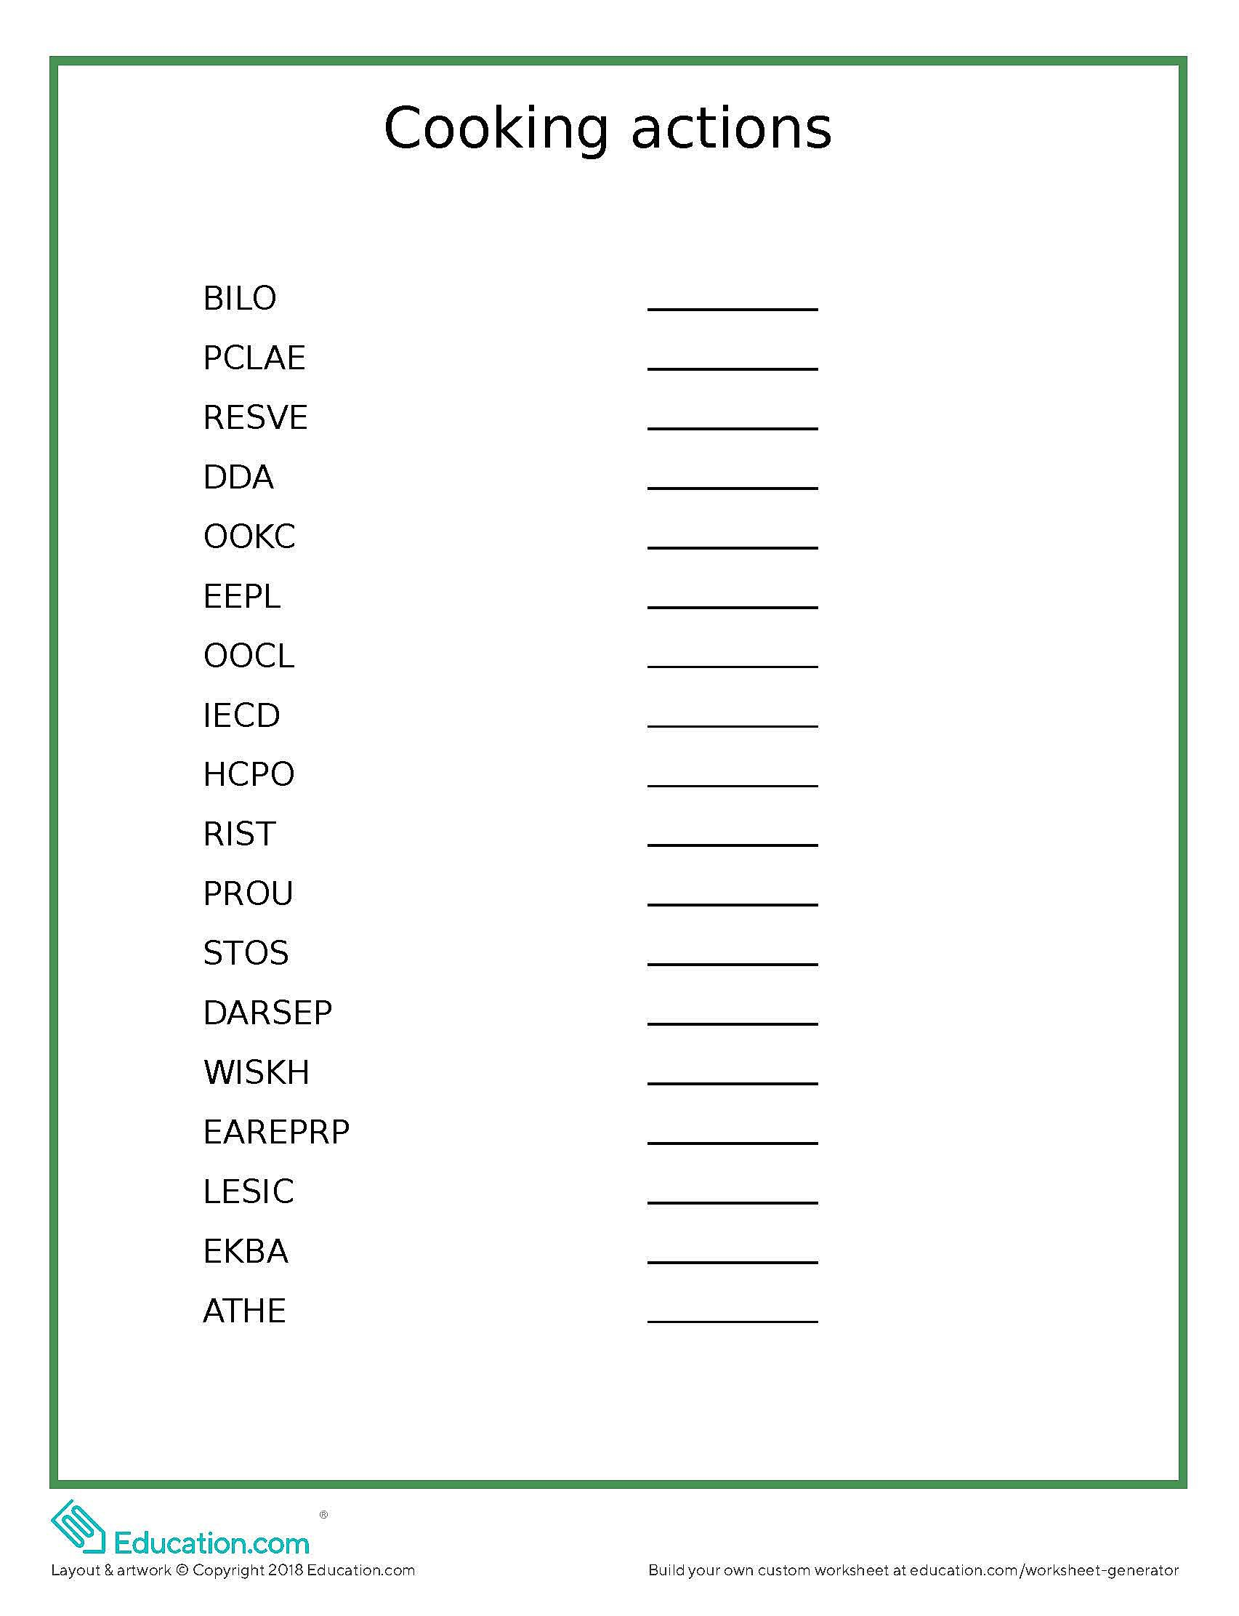

 

 

 

 

***Situation 1***

**Last month you were a cooking reality TV show participant. During the show you prepared a few dishes. Here are some photos showing the cooking of one of them. Tell us about it.**

**What kind of dish are you cooking? What ingredients are you cooking with? What preparation methods are you using?**

***Situation 2***

**Last month you were a cooking reality TV show participant. During the show you prepared a few dishes. Here are some photos showing the cooking of one of them. Do you remember it?**

**Tell us about your food making experience during the show. Was it difficult for you to cook different dishes? Were there any troubles? How did you solve them? What results have you achieved?**

***Situation 3***

**Last month you were a cooking reality TV show judge. During the show each participant prepared a few dishes. Here are some photos showing the cooking of one of them. Do you remember it? How did you rate it and why?**

**Tell us about the participants cooking skills. Were they well prepared to participate in such show? Was it difficult for you to judge them and why? Was there any unexpected situation? What are your wishes for future participants?**

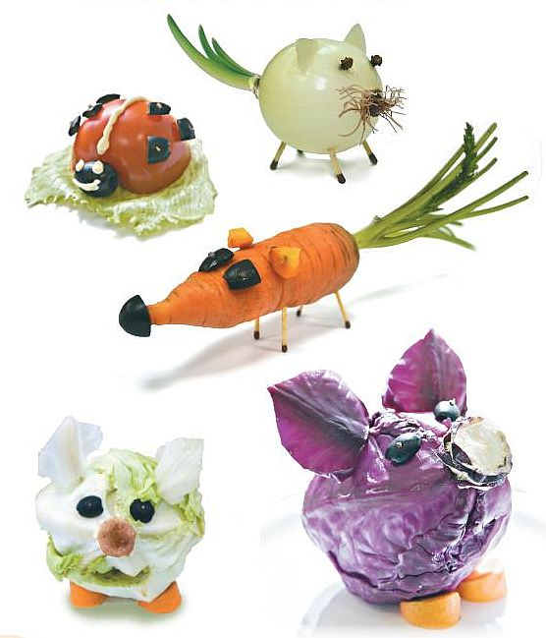

***Situation 1***

**Here are some photos shown animals made of food. Share your opinion on them.**

**Do you like them? Can you name all animals shown in the photos? What food are they made of? Is it difficult to do such things? Why? Did you make something like this using food?**

***Situation 2***

**You are a person who makes animals using food. Some of your works are shown in these photos. Other students like them a lot. They also have a few questions to ask you.**

***Examples:***

**How did you get the idea to make such food animals?**

**What food are they made of? Have it been cooked?**

**I want to make such animals myself. Describe step by step the process of making one of the animals, please.**

***Situation 3***

**Here are some photos shown animals. They look like unusual, don`t they? Did you guess what food they are made of?**

**Think and write down your own “recipe” of making another animal using food.**



